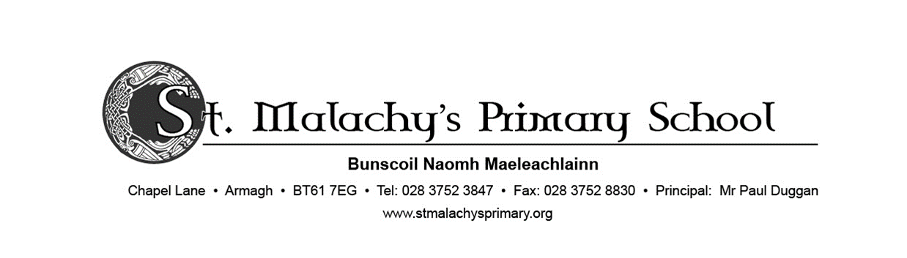



**Dear Parent/Guardian,**

St Malachy’s Primary School has always placed a high value on our communications. We plan on rolling out a new updated version of our app – the instructions for which you will find here.

The app is now live and will allow us to communicate with you in real-time bringing you instant alerts and notifications.

We are asking that all parents/guardians support this new form of communication by downloading the app to your smartphone devices. In these particularly challenging times, it is important that we have a reliable and effective channel to quickly reach you with up-to-date information. We hope to send out all school communications on the app and this will help us to reduce our use of paper.

The App can be downloaded at no charge from the Apple App Store and Google Play Store by following the steps outlined on the next page. Thank you for your support.

Yours sincerely,

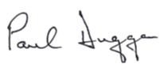

________

Mr P Duggan

**Principal**

Follow the 3 steps below to get the app

Open the ***App Store*** on your Apple device or the ***Play Store*** on your Android device.

In the search bar, type **Primary365**

Look out for this icon (right) in the search results.

Press *Get* or *Install*.



Once installed on your device, open the app. You will be prompted to enter a license code which has been sent out by text.

Enter the code and continue.

(**Allow Notifications** if prompted)

**Choose your profile** to receive notifications on your device. If you are a parent, select the **Parent** option and then tick the year group of your child /children and/or any interest group.

e.g. Parents of Primary 3 pupils should select the Parent option, then select Primary 3. **Press the save button** to finish the set up.

