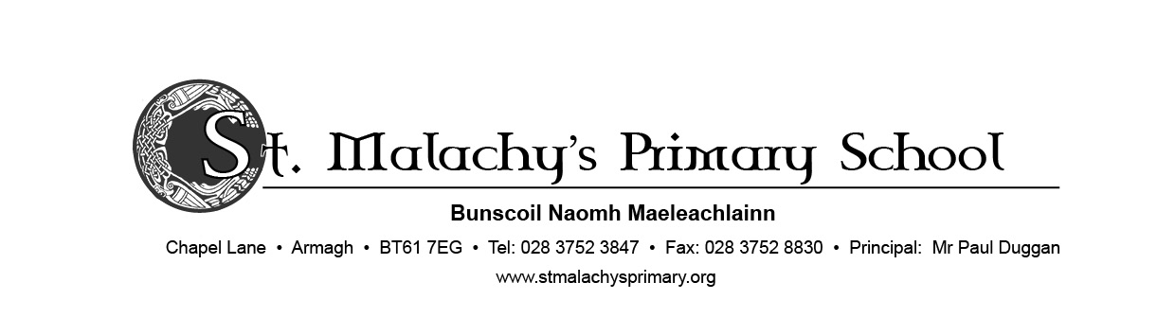19 August 2020

Dear Parents,

We appreciate this is a worrying time for parents, children and staff. Please be assured our preparations for re-opening on Monday 24th August have been thorough. Our Board of Governors met and provided excellent professional guidance. We have a very thorough Risk Assessment completed and ratified by the Board of Governors. Our concern at all times is the health and safety of both children and staff and we will therefore operate strict class bubbles at all times.

The school will operate with staggered opening and leaving times. These times will be assigned according to surname. Times are as follows

Week beginning 24th August

|  |  |  |
| --- | --- | --- |
| **Surname** | **Drop Off** | **Pick Up P2-P7** |
| A-I | 8:45am | 12:00 |
| J-Mc | 9:00am | 12:15 |
| Mo-Z | 9:15am | 12:30 |

Week beginning Tuesday 1st September

|  |  |  |  |
| --- | --- | --- | --- |
| **Surname** | **Drop Off** | **Pick Up P2-P3** | **Pick up P4-P7** |
| A-I | 8:45am | 1:45pm | 2:45pm |
| J-Mc | 9:00am | 2:00pm | 3:00pm |
| Mo-Z | 9:15am | 2:15pm | 3:15pm |

Children must be dropped off and collected at the school gates at their allocated time. When dropped off, children should walk straight to their classroom where they will be supervised by a staff member allocated to their class social bubble. We would request that you do observe social distancing at the gates and do not congregate there. If you are a working parent and your assigned time is not suitable, please email the school at [info@stmalachys.armagh.ni.sch.uk](mailto:info@stmalachys.armagh.ni.sch.uk) and we will try to accommodate your needs.

Our medical advice is that handwashing with soap is the most effective means of protection against the virus. Children will be required to wash their hands as soon they come into their classroom and at regular intervals throughout the

school day. Children will also reinforce *‘catch it, bin it, kill it’* practices throughout the school.

We would ask that children wear full school uniform as normal. There is no requirement to wash their uniform every day, but it is advisable to change their uniform upon return from school. They can alternate between school and PE uniform to facilitate washing.

School will be closed on Monday 31st August for the Bank Holiday. Dinners will be provided from Tuesday 1st September and will be served in the dining hall at 2 separate sittings and keeping classes socially distant. We are in the process of establishing an app called ‘School Money’ to enable you to pay for school dinners online, in order to alleviate the handling of cash. Registration details and further information will be sent by text on Friday 28th August. Please sign up to this before Tuesday 1st as we will no longer be accepting cash.

Children will be provided with all stationery, pencils, pens etc that they will need and will be stored in individual plastic wallets that will remain in school. Children may bring in lunch boxes, water bottles etc, daily in washable plastic containers. Lunches will be eaten in classrooms. We will not be distributing milk so children should bring their own water in a plastic bottle. Children may also bring in fruit for morning snack. Please remember that we are a NUT FREE school.

We have 2 new members of staff this year, Mrs Bronagh Glackin will be teaching P3 and Mrs Caitriona Donnelly will teach P5 children. We welcome both members of staff to St Malachy’s.

If you wish to speak to me or your class teacher we request that you make an appointment either by phone or email to [info@stmalachys.armagh.ni.sch.uk](mailto:info@stmalachys.armagh.ni.sch.uk). We will be unable to meet parents without an appointment.

We realise that in order to protect and safeguard our social bubble regime, it is not practical or safe at the moment to operate either breakfast club or afterschool activities. We apologise for any inconvenience this may cause, but the health and safety of all is our primary concern. A hard copy of this letter will be given to children next week upon return to school. Please update your contact details to ensure that you receive all communication.

Yours sincerely



PAUL DUGGAN

Principal