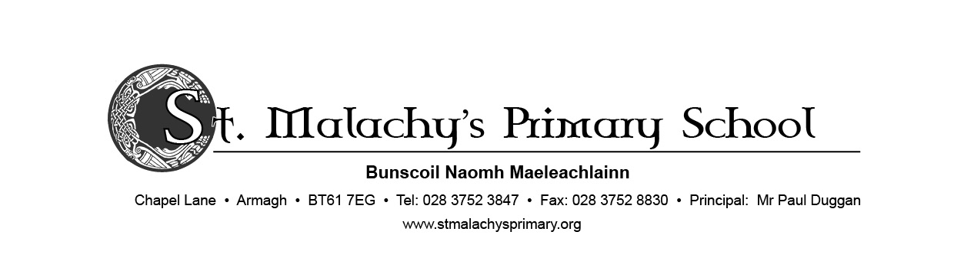19 August 2020

**Dear Primary 1 Parents,**

We appreciate this is a worrying time for parents, children and staff. Please be assured our preparations for re-opening on Monday 24th August have been thorough. Our Board of Governors met and provided excellent professional guidance. We have a very thorough Risk Assessment completed and ratified by the Board of Governors. Our concern at all times is the health and safety of both children and staff and we will therefore operate strict class bubbles at all times.

The school will operate with staggered opening and leaving times which be provided to you next week on the day that your child comes to school. These times will be assigned according to surname.

Children from P2-P7 must be dropped off and collected at the school gates. In order to help P1 children settle in for the first few weeks, parents may take them to the P1 door on the left side of the school building, where they will be met by Mrs Kearney and Ms McVeigh. Parents should then walk around the back of the school in a one-way system and exit the school via the large gate in the front playground. We would request that you observe social distancing whilst on the school grounds.

Your child will only attend school on one assigned day next week from 9am-11am. Please send a plastic water bottle and fruit with you child for their morning snack.

Our medical advice is that handwashing with soap is the most effective means of protection against the virus. Children will be required to wash their hands as soon they come into their classroom and at regular intervals throughout the

school day. Children will also reinforce *‘catch it, bin it, kill it’* practices throughout the school.

We would ask that children wear full school uniform as normal. There is no requirement to wash their uniform every day, but it is advisable to change their uniform upon return from school. They can alternate between school and PE uniform to facilitate washing. Please ensure that all uniform and fruit containers or water bottles are clearly labelled with your child’s name.

School will be closed on Monday 31st August for the Bank Holiday. Dinners will be provided from 14th September and will be served in the dining hall at 2 separate sittings and keeping classes socially distant. We are in the process of

establishing an app called ‘School Money’ to enable you to pay for school dinners online, in order to alleviate the handling of cash. Registration details and further information will be sent by text on Friday 28th August. Please sign up to this before 14th September as we will no longer be accepting cash.

Children will be provided with all stationery, pencils, pens etc that they will need and will be stored in individual plastic wallets that will remain in school. Children may bring in lunch boxes, water bottles etc, daily in washable plastic containers. Lunches will be eaten in classrooms. We will not be distributing milk so children should bring their own water in a plastic bottle. Children may also bring in fruit for morning snack. Please remember that we are a NUT FREE school.

We have 2 new members of staff this year, Mrs Bronagh Glackin will be teaching P3 and Mrs Caitriona Donnelly will teach P5 children. We welcome both members of staff to St Malachy’s.

If you wish to speak to me or your class teacher we request that you make an appointment either by phone or email to [info@stmalachys.armagh.ni.sch.uk](mailto:info@stmalachys.armagh.ni.sch.uk). We will be unable to meet parents without an appointment.

We realise that in order to protect and safeguard our social bubble regime, it is not practical or safe at the moment to operate either breakfast club or afterschool activities. We apologise for any inconvenience this may cause, but the health and safety of all is our primary concern. A hard copy of this letter will be given to children next week upon return to school. Please update your contact details to ensure that you receive all communication.

Yours sincerely



PAUL DUGGAN

Principal